**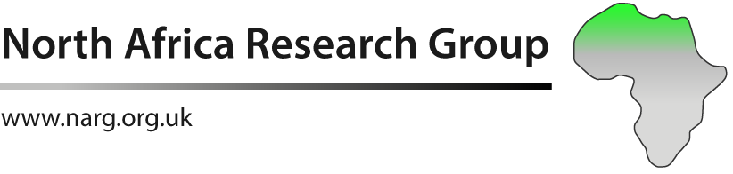**

**TUOM_4COLThe Early Cretaceous evolution on the Morocco Atlantic Margin: establishing an integrated stratigraphic framework and depositional model for the Berriasian to early Barremian interval**

**Fully funded PhD studentship: full fees and living allowance**

**Host University: University of Manchester**

**Supervisors: Prof Jonathan Redfern, Dr Luc Bulot, Dr Stefan Schroeder, Prof Giovanni Bertotti**

**Outline and Aims**

A fully funded PhD studentship to start in January 2018 to examine the evolution of Berriasian to Barremian interval of the Early Cretaceous depositional system that outcrops along the Atlantic margin of Morocco north of Agadir. The study will define a new biostratigraphic type section, integrating ammonite, calpionellid calcareous nannofossil and benthic foraminifera analysis, with C13/O18 isotope stratigraphy and sequence stratigraphic interpretation. It will focus on refining our understanding of the stratigraphic architecture, age relationships, paleogeography and facies trends across the margin. The work will involve extensive outcrop studies and also integrate data from existing wells (cuttings data and wireline log data).

A focus of the study will also be to characterise the coral buildups in the Hauterivian : provide improved age constraint, map their geometry and assess the significance and impact these buildups have on post Hauterivian paleogeography and palaeotopography. The project will also assess potential salt tectonic movements in relation with condensation and hiatuses that affects the early Lower Cretaceous sequences.

Integration will be made with work completed in Morocco by NARG on the younger Barremian to Aptian section and the results will be correlated to global type sections.

The Early Cretaceous is a potential reservoir for hydrocarbons offshore, and this work will further constrain the interval and refine models for the depositional system that controls deep-water reservoir development.

**North Africa Research Group (NARG)**

The North Africa Research Group (NARG) is an integrated research group combining the strengths of the Universities of Manchester and TuDelft, funded by a large consortium of industry companies (BP,Repsol, Statoil, Cairn, Woodside, Chevron). The group is undertaking extensive projects across Northern Africa, and we are undertaking a series of studies examining Mesozoic depositional systems on/offshore the Atlantic seaboard, in western Morocco and along the margin to Mauritania and Senegal. Morocco, together with the conjugate margin in Nova Scotia, is an area of active oil and gas exploration, and the results from this study will have an important input to understanding the petroleum system and development of the passive margin.

**Requirements:**

We seek a highly motivated candidate with the following skills:

* 1st , high 2.1 or masters in geology / petroleum geoscience
* good background in biostratigraphy, sedimentology and stratigraphic principles, ideally having conducted similar projects at undergraduate or master level
* knowledge of carbonate depositional systems
* Independent worker with good organizational skills
* team working skills, with ability to integrate with other team members and industry partners
* knowledge of French is an advantage

**University of Manchester**

The Basin Studies and Petroleum Geoscience Group at Manchester has 12 academic staff and over 35 PhDs, and offers access to world-leading facilities and research expertise for stratigraphic and sedimentological studies. Training is offered through specialist seminars within the group and the opportunity to take selected masters courses from the Petroleum Geoscience MSc. The successful candidate will also have opportunities to interact with and present results to industry partners, and will typically undertake a 3-month internship with one of our sponsor companies

We have extensive facilities, as may be expected in a world leading University, including SEM, cathode luminescence, x-ray tomography and an industry standard petrophysical laboratory,. The student will also access leading facilities for quantitative outcrop data collection, including LiDAR, a photogrammetry drone, and a full suite of software available to the group ; Polyworks ™, Petrel™ , ArcInfo™ Geoteric™ among others. The student will also utilise our in-house software Virtual Reality Geological Studio (VRGS), which enable rapid integration and interpretation of acquired digital outcrop data, and transfer to Petrel or similar software for mapping and interpretation.

**Full scholarship:** 3.5 years funding, includes all fees, living allowance and field expenses.

**Selected References:**

Luber T, L., Bulot, L.G., Redfern, J., Frau, C., Arantegui, A., Masrour, M., 2017. A revised ammonoid biostratigraphy for the Aptian of NW Africa: Essaouira- Agadir Basin, Morocco. Cretaceous Research. doi: 10.1016/j.cretres.2017.06.020

**Application:** please apply online at: <http://www.manchester.ac.uk/study/postgraduate/how-to-apply/> quoting this PhD advert and the lead supervisor Prof Jonathan Redfern. For additional details please email jonathan.redfern@manchester.ac.uk

Application should be submitted by December 1st 2017 Selected candidates will be called for interview in early December. The PhD will commence in January 2

**